**Project Name**

**Lake View Coffee (Coffee Application)**

**Faculty:**

**Mr. Listyo Edi Prabowo S.T**

Created by:

Muhamad Dani Setiawan (1820010114)

Class:

3SC5

**Continuing Education Program for Computing and Information Technology**

**Faculty of Engineering, University of Indonesia**

**2019**

PROJECT ON

*Lake View Coffee*

**Developed By**

**Name : - Muhamad Dani Setiawan**

NIIT

LAKE VIEW COFFEE

Batch Code : 3SC5

Start Date : December 10th, 2019

End Date : December 17th, 2019

Name of Coordinator : Mr. Listyo Edi Prabowo S.T

Name of Developer : Muhamad Dani Setiawan

Date Of Submission : December 18th, 2019

NIIT





CERTIFICATE

This is to certify that this report titled “Lake View Coffee apps”,embodies the original work done by me Muhamad Dani Setiawan in partial fulfillment of their course requirement at NIIT.

Coordinator:

Mr. Listyo Edi Prabowo S.T

ACKNOWLEDGEMENT

Thanks to Allah who has given the for giving us blessings, health, ability to be able to finish this Project with the title “Lake View Coffee”, without any of it we won’t be able to complete it right on time. Despite many hurdles and obstacles that we experienced in the course of the work, but we managed to finish it properly.

We also who have guided and have benefited a lot from the feedback and suggestions given to us in completing this project especially Mr Listyo Edi Prabowo

In arranging this project, the writer truly get lots challenges and obstructions but with help of many individuals who can’t be mentioned one by one, those obstructions could have passed. writer also realized there are still many mistakes in process of writing this paper. This paper may have some flaws and imperfections, we hope readers will give comments and suggestions.

Depok Desember 18th, 2019

SYSTEM ANALYSIS

Lake View Coffee application is a coffee application to replace the menu book in order to facilitate ordering when ordering coffee, this application consists of three menus namely the Home menu, Order Coffee menu, Trasaction History menu, in the home menu we can see about the coffee description, inside order menu we can order coffe by entering the available table number, in the transaction menu we can see transaction details and change orders if something goes wrong.

**DESIGN INTERFACE**

**Layout :**

Home Menu

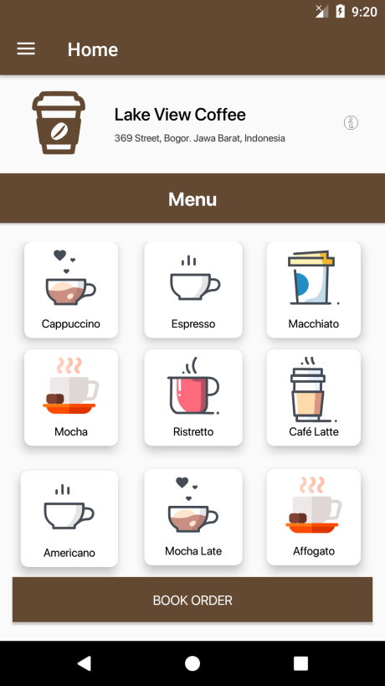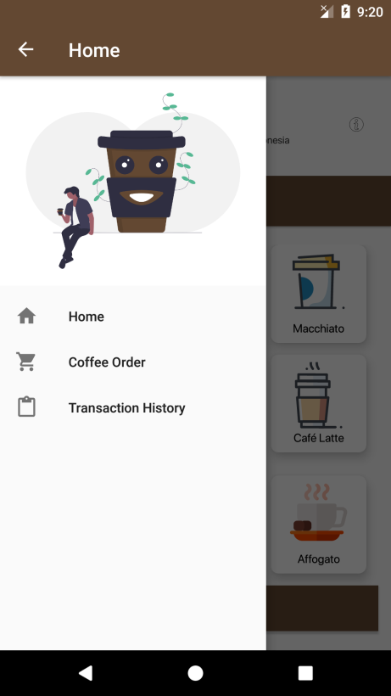

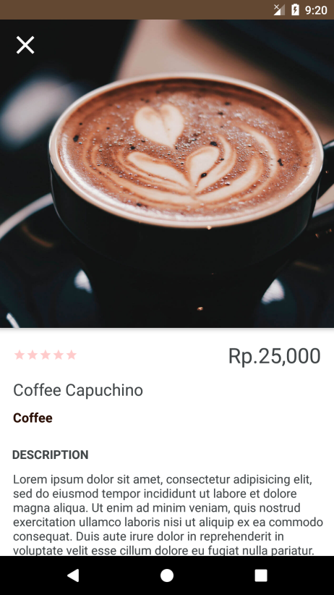

**Layout**

Order Menu

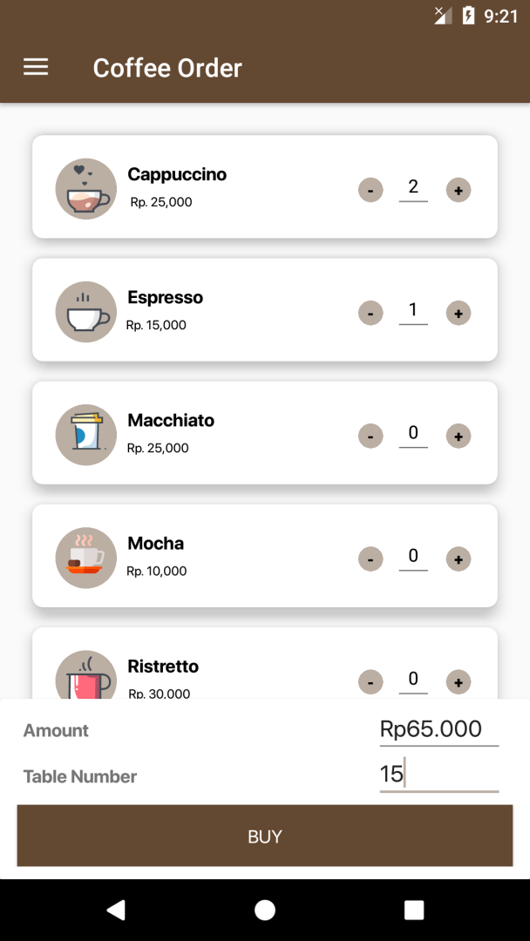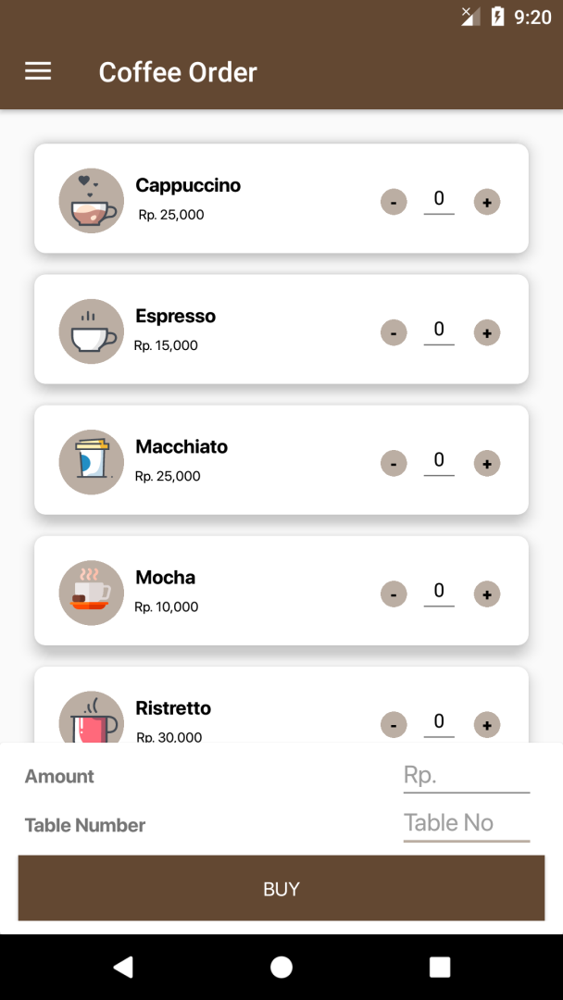

**Layout**

Transaction History And Update Transaction

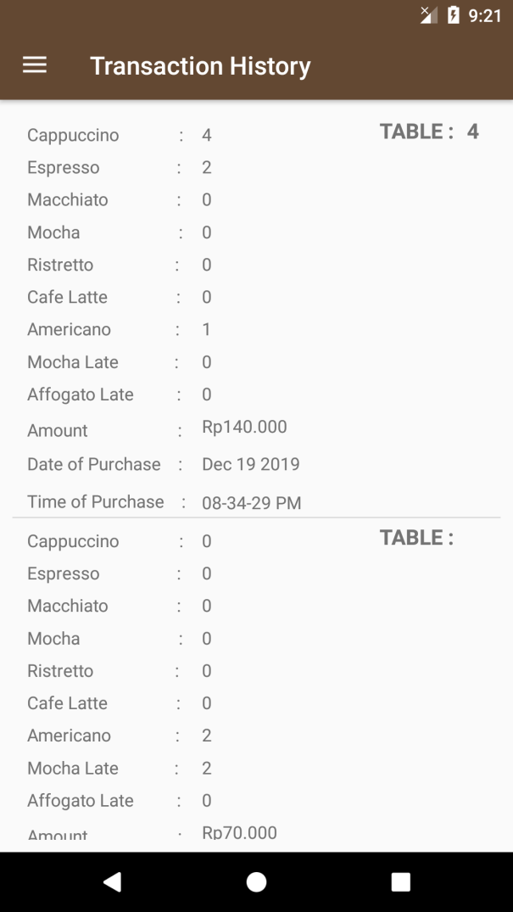

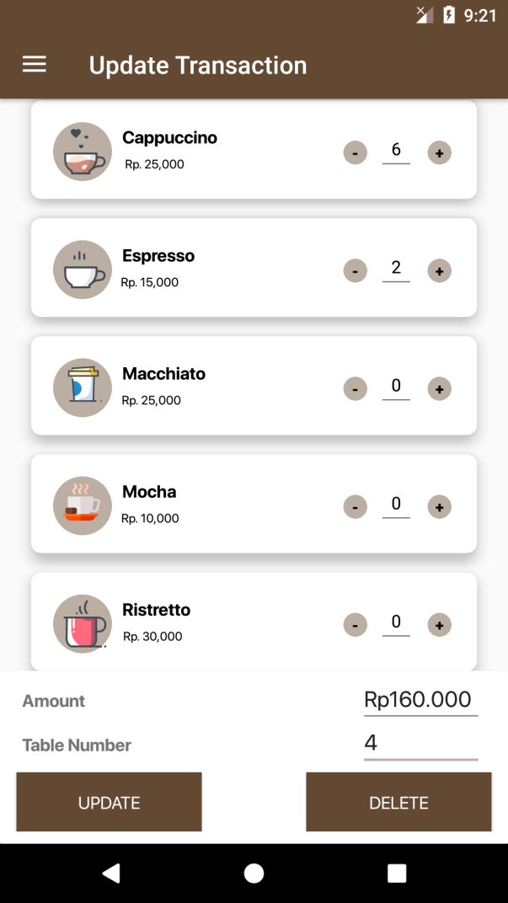

**CONFIGURATION**

**Hardware :** HP Pavilion Gaming 15 Ryzen 5 3550H VGA 1050 3GB, RAM 16 GB, SSD 512 GB

**Operating System ;** Windows 10 and Android Pie 9.0

**Software :** Android studio .

|  |  |  |
| --- | --- | --- |
| **PROJECT FILE DETAILS** | | |
| **No** | **File Name** | **contains** |
| 1. | Manifest | Contain androidmanifest,xml |
| 2. | Java | ActivityCoffeeHome  ActivityCoffeeOrder  ActivityCoffeeTransaction  ActivityCoffeeProduct  ActivityCoffeeModify  DatabaseHelper  DBManager |
| 3. | Res | Anim , drawable , layout ,menu , mipmap , values |